Name :- Rohit Gawade Roll No :- 14

Batch :- T1

import pandas as pd

# Load dataset without header, first row is first transaction dataset = pd.read_csv('Market.csv', header=None) print(dataset.head())

In [1]:

 | 0 | 1 | 2 |  | 3 |  | 4 | \
0 | shrimp | almonds | avocado | vegetables | mix | green | grapes
1 | burgers | meatballs | eggs |  | NaN |  | NaN
2 | chutney | NaN | NaN |  | NaN |  | NaN
3 | turkey | avocado | NaN |  | NaN |  | NaN
4 mineral water milk energy bar whole wheat rice green tea

5 6 7 8 9 \
- whole weat flour yams cottage cheese energy drink tomato juice
- NaN NaN NaN NaN NaN
- NaN NaN NaN NaN NaN
- NaN NaN NaN NaN NaN
- NaN NaN NaN NaN NaN

10 11 12 13 14 15 \
- low fat yogurt green tea honey salad mineral water salmon
- NaN NaN NaN NaN NaN NaN
- NaN NaN NaN NaN NaN NaN
- NaN NaN NaN NaN NaN NaN
- NaN NaN NaN NaN NaN NaN

16 17 18 19
- antioxydant juice frozen smoothie spinach olive oil
- NaN NaN NaN NaN
- NaN NaN NaN NaN
- NaN NaN NaN NaN
- NaN NaN NaN NaN

In [2]:
# Convert dataset into list of transactions (each transaction is a list of items)
transactions = []
for i in range(len(dataset)): transaction = []
for item in dataset.iloc[i]: if pd.notna(item):
transaction.append(str(item)) transactions.append(transaction)

print(transactions[:5]) # print first 5 transactions
[['shrimp', 'almonds', 'avocado', 'vegetables mix', 'green grapes', 'whole weat flour', 'yams', 'cottage cheese', 'energy drink', 'tomato juice', 'low fat yogurt', 'green tea', 'honey', 'salad', 'mineral water', 'salmon', 'antioxydant juice', 'frozen smoothie', 'spinach', 'olive oil'], ['burgers', 'meatballs', 'eggs'], ['chutney'], ['turkey', 'avocado'], ['mineral water', 'milk', 'energy bar', 'whole wheat rice', 'green tea']]

from mlxtend.preprocessing import TransactionEncoder
from mlxtend.frequent_patterns import apriori, association_rules

# Transform transaction data for apriori input te = TransactionEncoder()
te_ary = te.fit(transactions).transform(transactions) df = pd.DataFrame(te_ary, columns=te.columns_)

# Generate frequent itemsets with support threshold (e.g. 0.01) frequent_itemsets = apriori(df, min_support=0.01, use_colnames=True) print(frequent_itemsets.head())
support itemsets
0 0.020397 (almonds)
1 0.033329 (avocado)
- 0.010799 (barbecue sauce)
- 0.014265 (black tea)
- 0.011465 (body spray)

import matplotlib.pyplot as plt import seaborn as sns

# Generate association rules with confidence threshold (e.g. 0.5) rules = association_rules(frequent_itemsets, metric='confidence', min_threshold=0.5)
print(rules.head())

# Create scatterplot of rules support vs confidence plt.figure(figsize=(10,6))
sns.scatterplot(data=rules, x='support', y='confidence', size='lift', legend=False, sizes=(20, 200))
plt.title('Association Rules: Support vs Confidence') plt.xlabel('Support')
plt.ylabel('Confidence') plt.show()

In [5]:

In [6]:

antecedents consequents antecedent support \
- (ground beef, eggs) (mineral water) 0.019997
- (milk, ground beef) (mineral water) 0.021997

consequent support support confidence lift representativity \
0 0.238368 0.010132 0.506667 2.125563 1.0
1 0.238368 0.011065 0.503030 2.110308 1.0

leverage conviction zhangs_metric jaccard certainty kulczynski
0 0.005365 1.543848 0.540342 0.040816 0.352268 0.274586
1 0.005822 1.532552 0.537969 0.044385 0.347493 0.274725
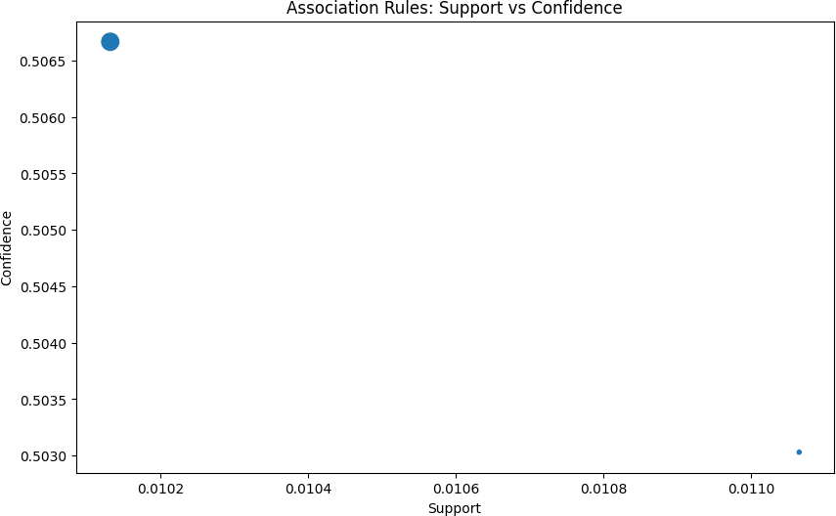

In [7]:
# List of different confidence values to test confidence_values = [0.5, 0.6, 0.7, 0.8, 0.9]

for conf in confidence_values:
rules_conf = association_rules(frequent_itemsets, metric='confidence', min_threshold=conf)
print(f'Confidence Threshold: {conf}, Number of Rules:
{len(rules_conf)}')
Confidence Threshold: 0.5, Number of Rules: 2 Confidence Threshold: 0.6, Number of Rules: 0 Confidence Threshold: 0.7, Number of Rules: 0 Confidence Threshold: 0.8, Number of Rules: 0 Confidence Threshold: 0.9, Number of Rules: 0

In [18]:
data = pd.read_csv('Market.csv', header=None)

# Preprocess: Create list of transactions from rows (skip NaN values) transactions = []
for i in range(len(data)):
items = [str(item) for item in data.iloc[i] if pd.notnull(item)] transactions.append(items)

# Convert transactions into one-hot encoded DataFrame te = TransactionEncoder()
te_ary = te.fit(transactions).transform(transactions) df = pd.DataFrame(te_ary, columns=te.columns_)

# Train Apriori (support threshold 0.01)
frequent_itemsets = apriori(df, min_support=0.01, use_colnames=True)

# Generate association rules (confidence 0.3)
rules = association_rules(frequent_itemsets, metric='confidence', min_threshold=0.3)

# Print the first 5 rules
print(rules[['antecedents', 'consequents', 'support', 'confidence', 'lift']].head())

# Visualize rules plt.figure(figsize=(10,6))
sns.scatterplot(data=rules, x='support', y='confidence', size='lift', sizes=(20,200), legend=False)
plt.title('Association Rules: Support vs Confidence') plt.xlabel('Support')
plt.ylabel('Confidence') plt.show()

# Show how rule count changes with confidence for min_conf in [0.3, 0.5, 0.7, 0.9]:
rules_conf = association_rules(frequent_itemsets, metric='confidence', min_threshold=min_conf)
print(f"Min confidence: {min_conf}, Number of rules: {len(rules_conf)}") antecedents consequents support confidence lift
0 (avocado) (mineral water) 0.011598 0.348000 1.459926
1 (burgers) (eggs) 0.028796 0.330275 1.837830
2 (cake) (mineral water) 0.027463 0.338816 1.421397
3 (cereals) (mineral water) 0.010265 0.398964 1.673729
4 (chicken) (mineral water) 0.022797 0.380000 1.594172

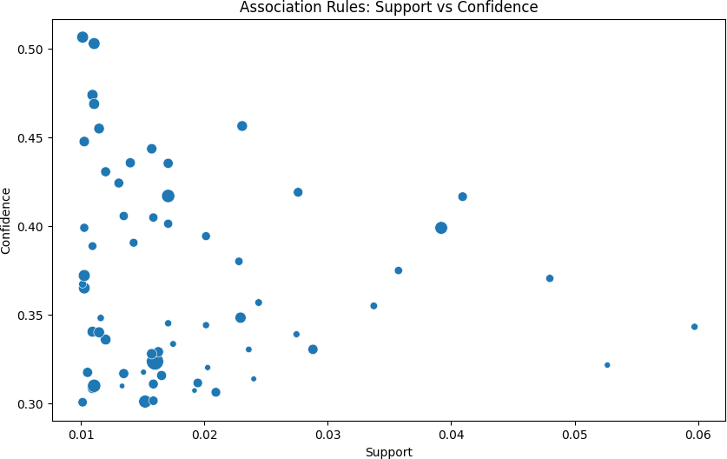

Min confidence: 0.3, Number of rules: 63 Min confidence: 0.5, Number of rules: 2 Min confidence: 0.7, Number of rules: 0 Min confidence: 0.9, Number of rules: 0

# Load dataset without headers
data = pd.read_csv('Market.csv', header=None)

In [21]:

# Generate transactions transactions = []
for i in range(len(data)):
transaction = [str(item) for item in data.iloc[i] if pd.notna(item)] transactions.append(transaction)

# Encode transactions for Apriori te = TransactionEncoder()
te_ary = te.fit(transactions).transform(transactions) df = pd.DataFrame(te_ary, columns=te.columns_)

# Train Apriori
frequent_itemsets = apriori(df, min_support=0.01, use_colnames=True) rules = association_rules(frequent_itemsets, metric='confidence', min_threshold=0.3)

print(rules[['antecedents', 'consequents', 'support', 'confidence', 'lift']].head())
antecedents consequents support confidence lift

0 | (avocado) | (mineral | water) | 0.011598 | 0.348000 | 1.459926
1 | (burgers) |  | (eggs) | 0.028796 | 0.330275 | 1.837830
2 | (cake) | (mineral | water) | 0.027463 | 0.338816 | 1.421397
3 | (cereals) | (mineral | water) | 0.010265 | 0.398964 | 1.673729
4 | (chicken) | (mineral | water) | 0.022797 | 0.380000 | 1.594172
In [ ]:

